DHCP - Worksheet

- As you work through the project, complete the network documentation sheet. The current access passwords have been included. Change and document all passwords. Create different passwords for each device and function. For IP addresses, if device receives address from DHCP, type DHCP. If statically assigned, type the IP Address | Points Possible | Points Awarded
Device Interface IP Address CIDR Secret Password Telnet Password  Stud 1-4 NIC DHCP /24 N/A N/A  Classroom Laptop NIC DHCP /24 N/A N/A  ClassSwitch VLAN1 192.168.1.3 /24 cisco cisco  OfficeSwitch VLAN1 192.168.1.2 /24 cisco cisco  Network Laptop NIC DHCP /24 N/A N/A  MgtRouter Ge0/0 192.168.2.2 /24 N/A N/A  Ge0/1 192.168.1.99 /24  DHCP Router Ge0/0 192.168.2.1 /24 cisco cisco  Ge0/1 192.168.3.1 /24  Ge0/2 192.168.4.1 /24  Serial 0/0/0 198.3.24.3 /24  WebSwitch VLAN1 192.168.3.2 /24 cisco cisco  WebServer NIC 192.168.3.3 /24 N/A N/A  AdminSwitch VLAN1 192.168.4.2 /24 cisco cisco  “C” Computers NIC DHCP /24 N/A N/A | 5

- Why is network communication blocked by the Management Router? Describe the problem and how you fixed it. | Points Possible | Points Awarded
The network downtime was caused by a rogue classroom device and restricted configurations on the Management Router. Because the router was not forwarding DHCP requests and remote administrative access (VTY) was disabled, a manual intervention was required to restore the routing path between the Office and Admin networks. | 3
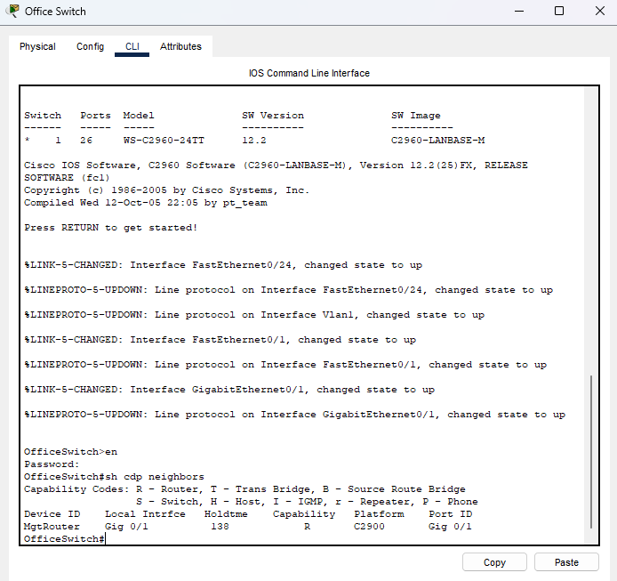 | 1

- Disable the ClassSwitch port that is connected to the “Rogue” Laptop. Secure the laptop until the Boss returns from his fishing trip. | Points Possible | Points Awarded
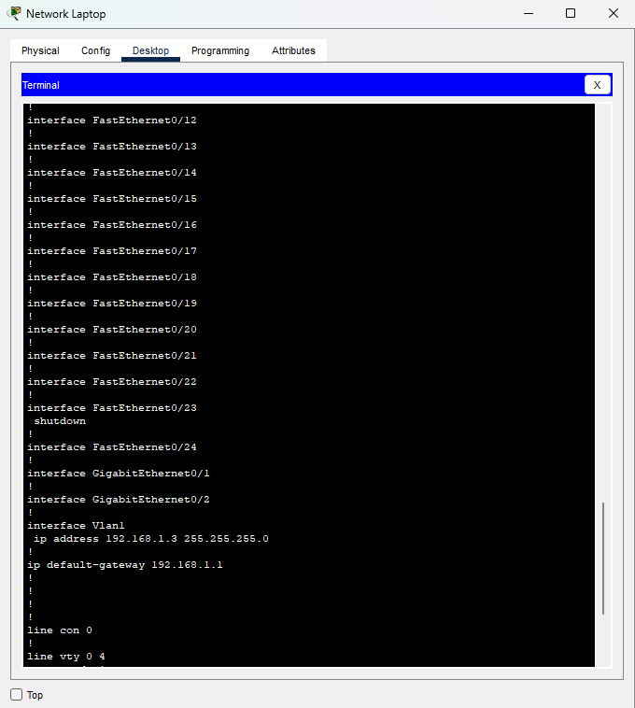 | 1

- Configure a DHCP Pool for the Classroom and Main Office network. Don’t forget to exclude addresses of statically configured devices (Network Laptop, ClassSwitch, OfficeSwitch, MgtRouter | Points Possible | Points Awarded
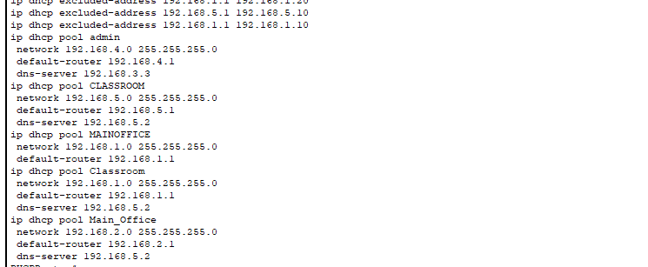 | 2

- Access any of the Stud# computers. Show the DHCP address assignment. Open the web browser and attempt to access the “Internet” (192.168.5.2). | Points Possible | Points Awarded
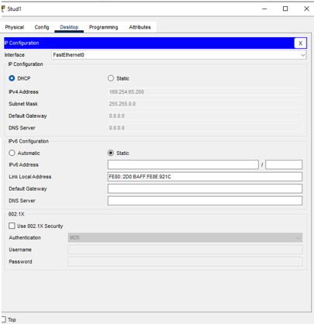 | 2

- Assuming the Stud# computers received DHCP assignments, what command(s) must have been configured on the gi0/1 interface of the MgtRouter? | Points Possible | Points Awarded
Command(s): The Management Router requires the ip helper-address 192.168.2.1 command on the interface facing the clients to forward DHCP requests to the DHCP Router. | 1

- Create DNS “A” records for the ClassSwitch, OfficeSwitch, WebSwitch, WebServer, and AdminSwitch. | Points Possible | Points Awarded
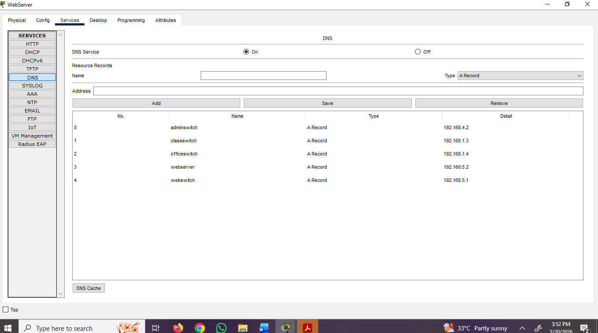 | 2

- From the Network Laptop, attempt to ping any of the resources assigned “A” records in DNS using the created name | Points Possible | Points Awarded
Replace this shape with a snip from the Network Laptop of a successful ping of a resource using the DNS name. | 1

- Configure the Admin Switch for telnet access. Take any other steps required to have a relatively secure switch (passwords, line configurations, console configurations) | Points Possible | Points Awarded
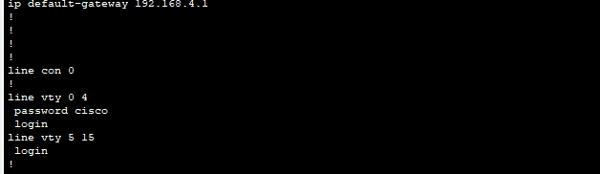 | 2

Total Possible Points | Total Points
20

